 A relay is an electrically operated switch. Current flowing through the coil of the relay creates a magnetic field which attracts a lever and changes the switch contacts. The coil current can be on or off so relays have two switch positions and they are doublethrow (changeover) switches. Relays allow one circuit to switch a second circuit which can be completely separate from the first. For example a low voltage battery circuit can use a relay to switch a 230V AC mains circuit. There is no electrical connection inside the relay between the two circuits; the link is magnetic and mechanical.

The coil of a relay passes a relatively large current, typically 30mA for a 12V relay, but it can be as much as 100mA for relays designed to operate from lower voltages. Most ICs (chips) cannot provide this current and a transistor is usually used to amplify the small IC current to the larger value required for the relay coil. The maximum output current for the popular 555 timer IC is 200mA so these devices can supply relay coils directly without amplification.

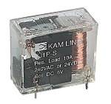 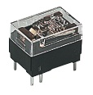

Relays are usually SPDT or DPDT but they can have many more sets of switch contacts, for example relays with 4 sets of changeover contacts are readily available. Most relays are designed for PCB mounting but you can solder wires directly to the pins providing you take care to avoid melting the plastic case of the relay. The animated picture shows a working relay with its coil and switch contacts. You can see a lever on the left being attracted by magnetism when the coil is switched on. This lever moves the switch contacts. There is one set of contacts (SPDT) in the foreground and another behind them, making the relay DPDT.

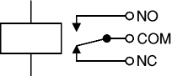

The relay's switch connections are usually labeled COM, NC and NO:

* **COM** = Common, always connect to this, it is the moving part of the switch.
* **NC** = Normally Closed, COM is connected to this when the relay coil is **off**.
* **NO** = Normally Open, COM is connected to this when the relay coil is **on**.